**Moving an EC2 Instance to Another Region**

**(Mumbai to Singapore)**

This guide explains how to move an EC2 instance from Mumbai (ap-south-1) to Singapore (ap-southeast-1) using an AMI (Amazon Machine Image).

**Step 1: Create an AMI (Backup) of Your EC2 Instance**

1. Open the AWS EC2 console in the Mumbai region.
2. Find and select the instance you want to move.
3. Click **Actions** > **Image and templates** > **Create image**.
4. Name the AMI and add a short description.
5. Click **Create Image** and wait until the process is complete.

**Step 2: Copy the AMI to Singapore**

1. Go to **EC2 Dashboard** > **Images** > **AMIs**.
2. Select the AMI you just created.
3. Click **Actions** > **Copy AMI**.
4. Choose **Singapore (ap-southeast-1)** as the new region.
5. Click **Copy AMI** and wait for it to finish.

**Step 3: Launch a New Instance in Singapore**

1. Switch to **Singapore (ap-southeast-1)** in the AWS console.
2. Go to **EC2 Dashboard** > **AMIs**.
3. Select the copied AMI and click **Launch instance from AMI**.
4. Pick an instance type (**t2.micro** for free tier).
5. Set up networking (VPC, subnet, security group as needed).
6. Create and download a new key pair.
7. Click **Launch Instance**.

**Final Result**

The EC2 instance was successfully moved from Mumbai to Singapore with little downtime. The new instance is now running in the Singapore region.

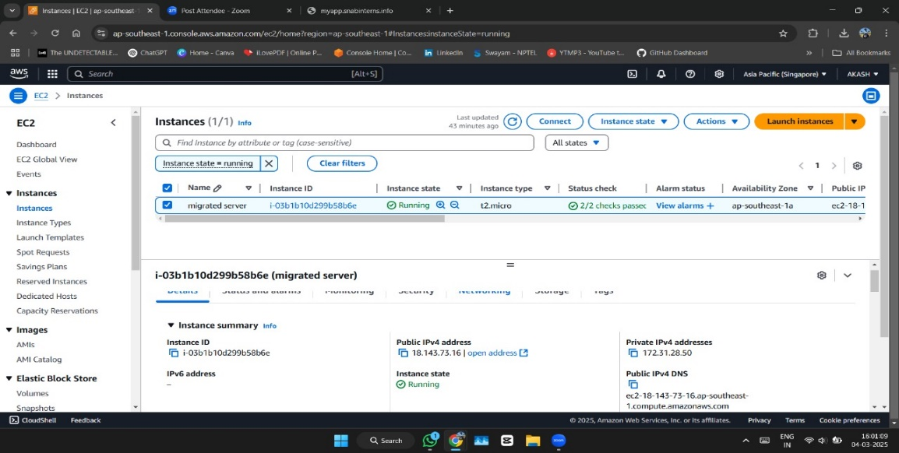

**Enable AWS Systems Manager (SSM) for EC2**

**Step 1: Install the SSM Agent**

Most Amazon Linux and Ubuntu AMIs come with the SSM agent pre-installed. If it’s missing, install it manually:

**For Amazon Linux 2 / Amazon Linux 2023:**

CopyEdit

sudo dnf install -y amazon-ssm-agent

**For Ubuntu:**

CopyEdit

sudo snap install amazon-ssm-agent

**Step 2: Attach an IAM Role to the EC2 Instance**

Your instance needs permissions to connect to AWS Systems Manager.

1. Go to **AWS IAM Console** → **Roles**.
2. Click **Create Role** → Select **AWS Service** → Choose **EC2**.
3. Attach the policy **AmazonSSMManagedInstanceCore**.
4. Name the role and create it.
5. Attach this role to your EC2 instance:
   * Go to **EC2 Dashboard** → Select your instance.
   * Click **Actions** → **Modify IAM Role**.
   * Attach the new role and save changes.

**Step 3: Connect to Your EC2 Instance via AWS Systems Manager**

1. Open the **AWS Systems Manager Console**.
2. Navigate to **Session Manager**.
3. Click **Start Session** and select your EC2 instance.
4. Click **Start Session** to connect remotely **without SSH keys**.

**Final Result**

Your EC2 instance is now connected to AWS Systems Manager, allowing you to manage it **without using SSH keys**.

